Project name : **InvoiceApp**

Please find below basic outline structure of this application.

2 Tire architecture (application layer and business layer)

Classes such as Customer, Category, Products, Cart, Invoice

Enum class Payment

Business layer:

Business logics on classes Customermanagement, CategoryManagement, productManagement, CartManagement.These classes manages Add, Update, Delete, Display operations.

Just to reduce number of line of cose, I have implimented validation part in application layer itself.

When you open this application,

1. It gives you interface to manage Customer details
2. Then Category manage interface
3. Next Product manage interface
4. Purchasing of product interface
5. Carting interface with payment option
6. Invoice interface
7. Custumer management

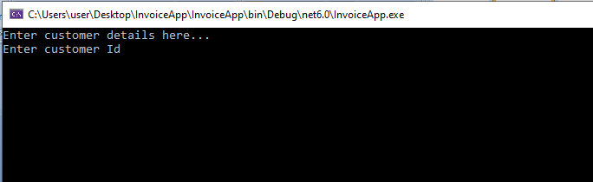

Fill the customer details here

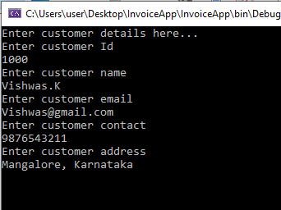

It shows success message and also gives option to add another customer details. You can type Y(yes) or N(no).

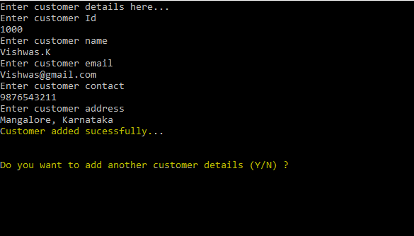

If you select N(no), it display customer details you have entered.

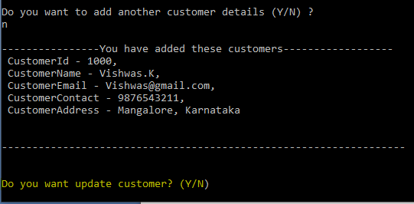

Next option to update customer detail.

Type Yes or No., if yes, then give the customer id which needs to be updated.

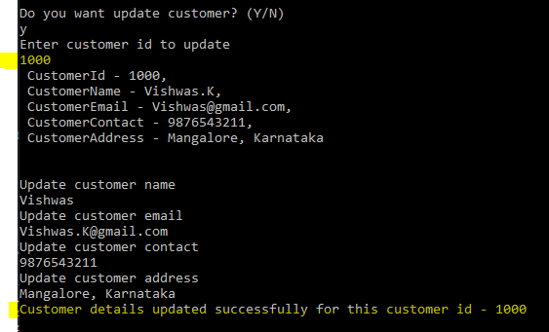

Next option is to delete customer details, you can choose Y or N. After “Delete” they it display all the available customer details.

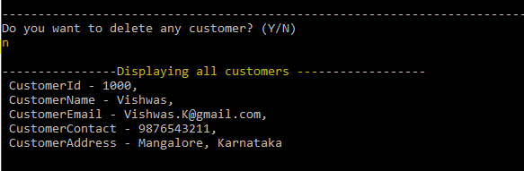

1. Category interface to add,update,delete and display all.

Here you can add multiple category details, also I have shown below validatin fail message

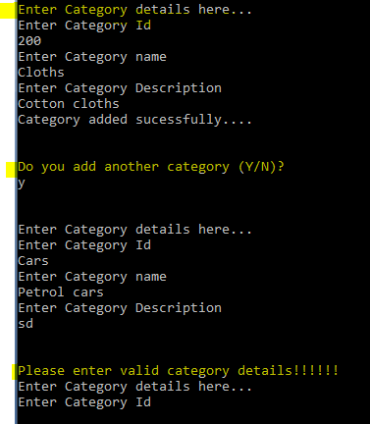

You can add multiple categories

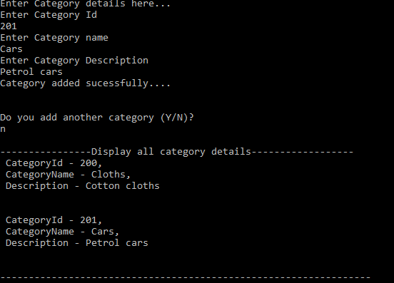

You can update or delete existing categories

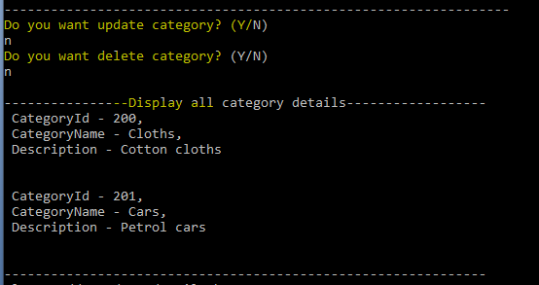

1. Product management to add, update, delete, display all products

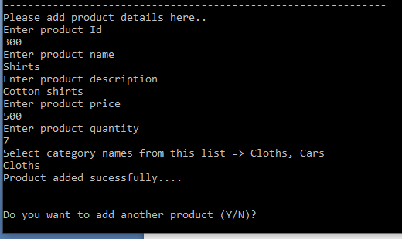

You can add multiple product for each categories

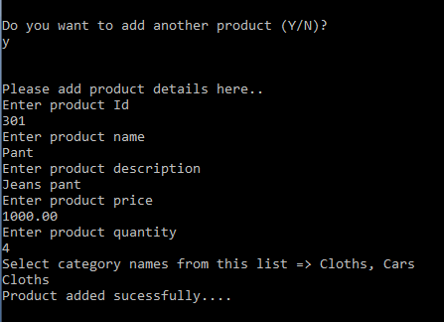

After completion of add product, it display all the product you have entered  
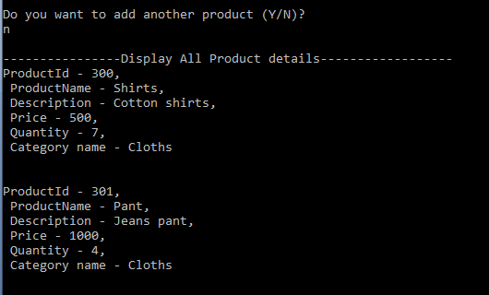

You have next option to “Update” product details

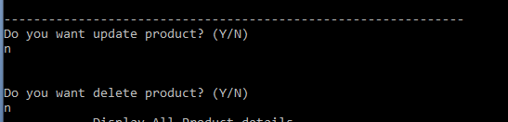

1. Purchase interface

Give a valid customer id before purchase any products, then select category of the product

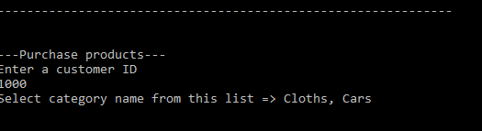

Select product from respective category

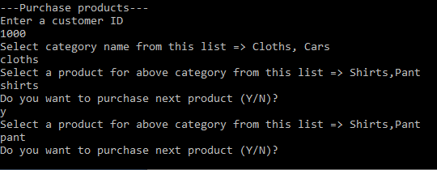

1. Cart interface

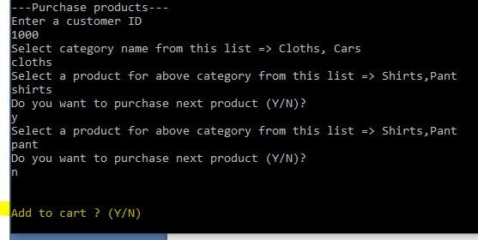

Cart interface display your customer details and product you have selected and payment option

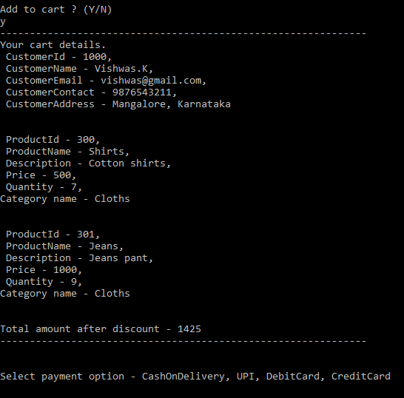

Select payment option from the list then shows payment successful message

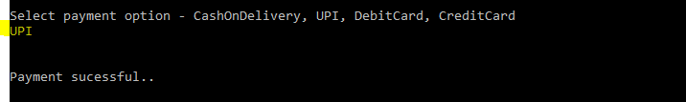

1. Invoice

